Travel Manitoba Campaign


“Canada’s Heart Goes Beyond”

By- Shruti Nigam
Table of Contents
Introduction 3
Objective 4
Key Publics 5
Strategy 7
TACTICS/EXAMPLES 9
Airbnb – “Until We Belong” (Día de los Muertos) 13
TD Bank – "All Gifts Are Good" (Eid & Christmas) 16
Event Ideas/Partnerships 17

Introduction
A subset of the “Canada’s Heart is Calling” campaign, “Canada’s Heart Goes Beyond” means Canada’s heart — Manitoba — goes beyond city life or typical leisure vacation (whether with family or friends).
“Canada’s Heart Goes Beyond” goes beyond just travel experience — it brings people together (show multi-generational members of a family); it builds relationships (show that through solo travellers connecting with Manitobans); it will leave you with a dreamy/fairytale/historic/magical experience (show that through Winnipeg’s historic buildings/university, feature small/local shops like the Elemental Witchery or The Witchery Hut, feature exchange district etc.); it brings diverse cultures together (show that not just through diversity but through, for example, Canadians celebrating cultures not their own [like Diwali or Manitoba Filipino Street Festival]).
“Canada’s Heart Goes Beyond” is more about showing connections (emotional & physical as in hugs) and sharing heartfelt stories through Travel Manitoba.

Objective

Achieve $2.5 billion in annual tourism expenditures by 2030 (50% growth)

Additional Goals:
- Lead Brand and Market Positioning
- Advance Destination Management
- Foster Collaboration and Build Support for Tourism

Key Publics
While the key publics would remain the same for “Canada’s Heart is Calling” campaign. As it’s subset, “Canada’s Heart Goes Beyond” will have its own niche key publics.
- Solo Travellers
These are people who seek comfort in travelling alone and crave authentic local interactions and foods. While some may prefer leisure vacation, these individuals mostly travel for local experience.

- Multi-Generational Families
These are families who are seeking meaningful trips that will bring together parents, grandparents, and kids. They’re interested in activities that nurture/support family bonding time.

- Soft Adventurers (Nature & Comfort Seekers)
These are nature lovers and seek comfort in exploring nature related places (like waterfalls & lakes). They are looking for a place to visit during different seasons that provide scenic, beautiful nature views. They want to visit a healing place.

- Romantic & Nostalgic Travellers
These are couples or booklovers who are looking for a fairytale-like escape (historic charm, dreamy landscapes, intimate local experiences). These are people who look for fairytale-like escape for both summer and winter seasons. In summer, they look for historic, dreamy and ethereal landscapes mostly related to greenery and nature, and in winter, they want to experience snow and holiday lights to fulfill their dreamy, romantic heart.

- Culture & History Enthusiasts
These are people who celebrate multiculturalism and are drawn to Winnipeg’s historic buildings, Exchange District, and Indigenous heritage. They are not just diverse ethnic groups but also allies who participate in cultural festivals and love culturally diverse food offerings. These may also include 2SLGBTQI+ travellers.

- Creative & Artistic Souls
Fans of local craftsmanship, indie shops, and storytelling, folk fests (e.g., The Witchery Hut, Exchange District’s arts scene). Could attract writers, photographers, and artists inspired by Manitoba’s charm.

This girl from Winnipeg posted this video on TikTok — a content that is similar to my vision. We can examine the comment section to get a better understanding of the content we’d produce. One comment said, “Someone needs to romanticize Winnipeg like this,” and those are the people I want to target. It is a risk, of course — since most Winnipeggers don’t see it that way — but like people say, “The biggest risk is not taking any risk.”

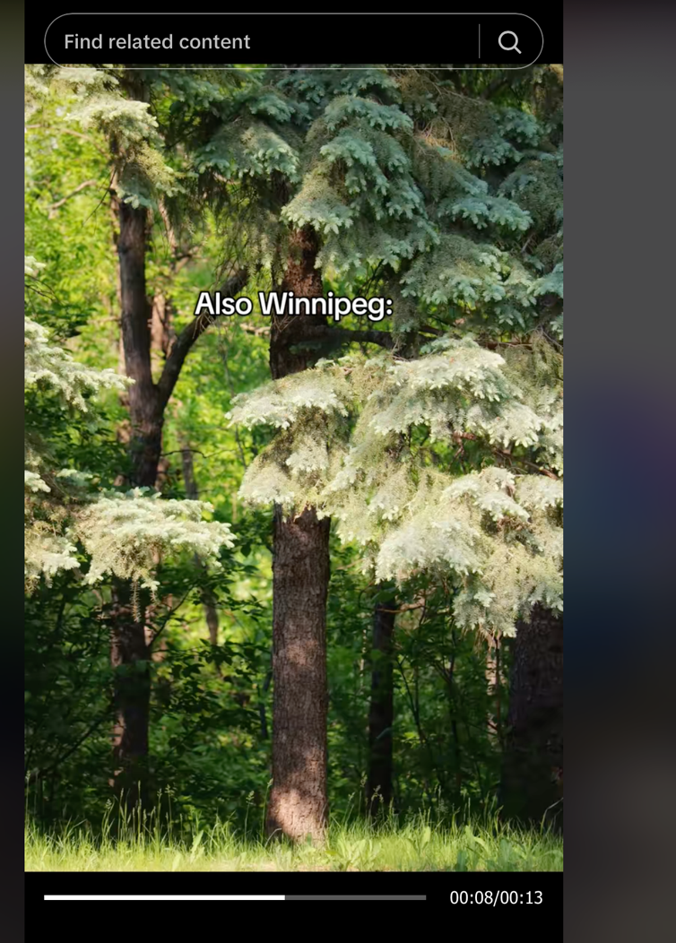

Strategy
The strategy for this campaign will focus on showing the same things from the “Canada’s Heart is Calling” campaign but with a different approach. This campaign will focus more on feelings — lasting effects Manitoba will leave on them — rather than listing things they’d simply find in Manitoba.
- Show that Manitoba values relationships — through travel.
- Show that Manitoba is a great location to immerse in a dreamy/fairytale escape (this one would include nature & book lovers too).
- Show that Manitoba is a great location for history enthusiasts
- Show that Manitoba celebrates multiculturalism and is inclusive.

Content Pillars
I would recommend leveraging Travel Manitoba’s TikTok platform for posting content and ads as you would find most key publics on there. Using trending sounds that align with each community (like nature lovers, booktok, family) would increase chances of getting seen.

- “Dreams Come Alive Here” (Dreamy/Fairytale Pillar):
Vibes/Tactics: Posts featuring misty lakes, golden hour prairie fields, cozy bookshops, Shelmerdine Garden Center, local mystical vibe of The Witchery Hut or Elemental Witchery, snow draped historic buildings, holiday lights, and northern lights.
Why: Taps into the universal desire for escapism and aligns with Manitoba’s historic charm.
- “Souls Connect Here” (Relationship Pillar):
Vibes/Tactics: Video series of stories of solo travellers, families travelling and Manitobans celebrating multiculturalism. For example, a non-Indigenous family learning something Indigenous related or a multi-generational family bonding and having a good time.
Why: Reinforces the core message of emotional connection and supports Manitoba’s inclusivity brand.
- “Cultures Live Here” (Culture & Heritage Pillar):
Vibes/Tactics: Explore historical and local sites like Exchange District and The Forks Market. Other features include museums, art museums, folk fest and food culture. This can also include Manitobans celebrating multiculturalism by participating in festivals that are not their own.
Why: Positions Manitoba as a living museum — not just observing culture but participating in it.

TACTICS/EXAMPLES
The above tactics/ideas could be used for all seasons in the next year (2025/2026) — summer, autumn, winter, and spring.

- Dreams Come Alive Here
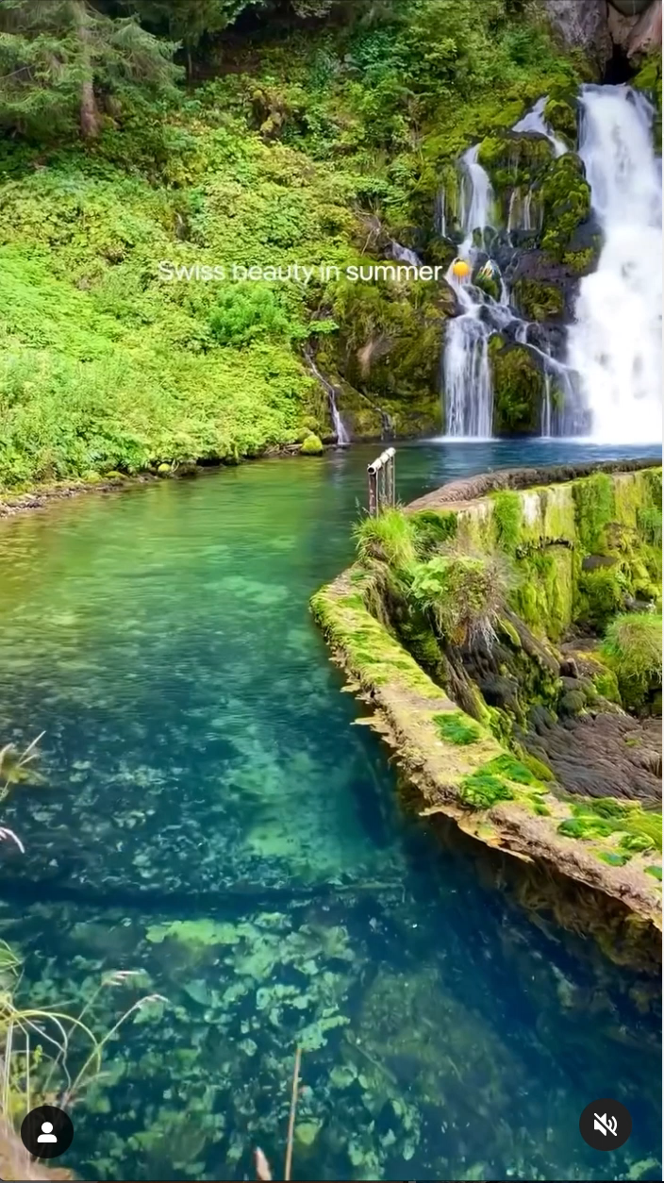
https://www.instagram.com/reel/DGqMqzBt-nt/?utm_source=ig_web_copy_link&igsh=MzRlODBiNWFlZA==
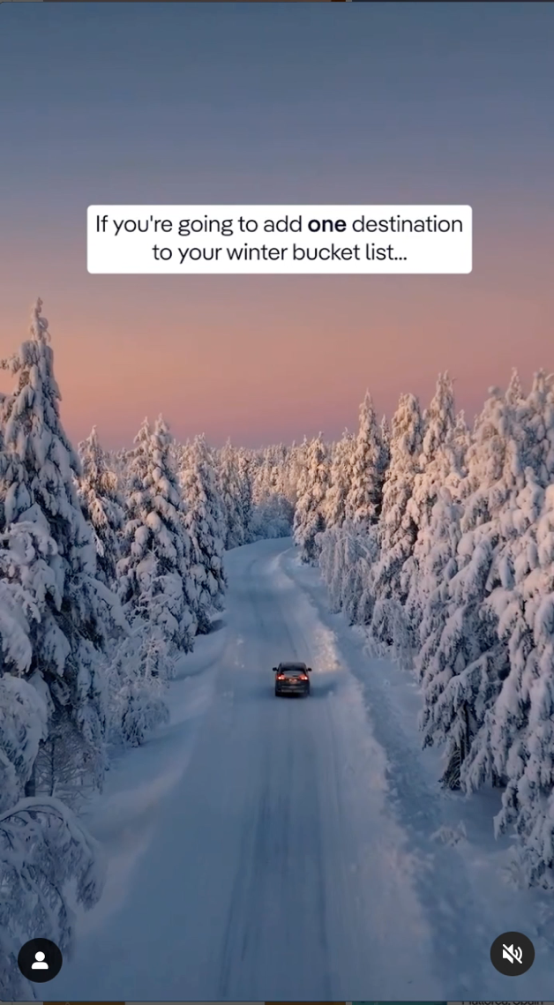
This Instagram page has some cool destination related reels we could take inspiration from.

https://www.instagram.com/reel/DFsY1wstkve/?utm_source=ig_web_copy_link&igsh=MzRlODBiNWFlZA==
TikTok inspirations: Includes both dark and bright nature aesthetic.
https://www.tiktok.com/@sralfilm/video/7498045371210419478?is_from_webapp=1&sender_device=pc&web_id=7499494988296930822

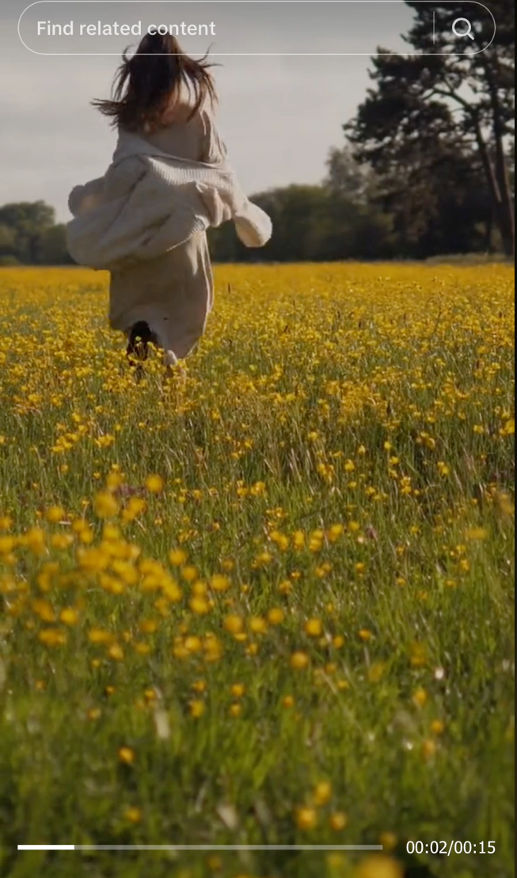
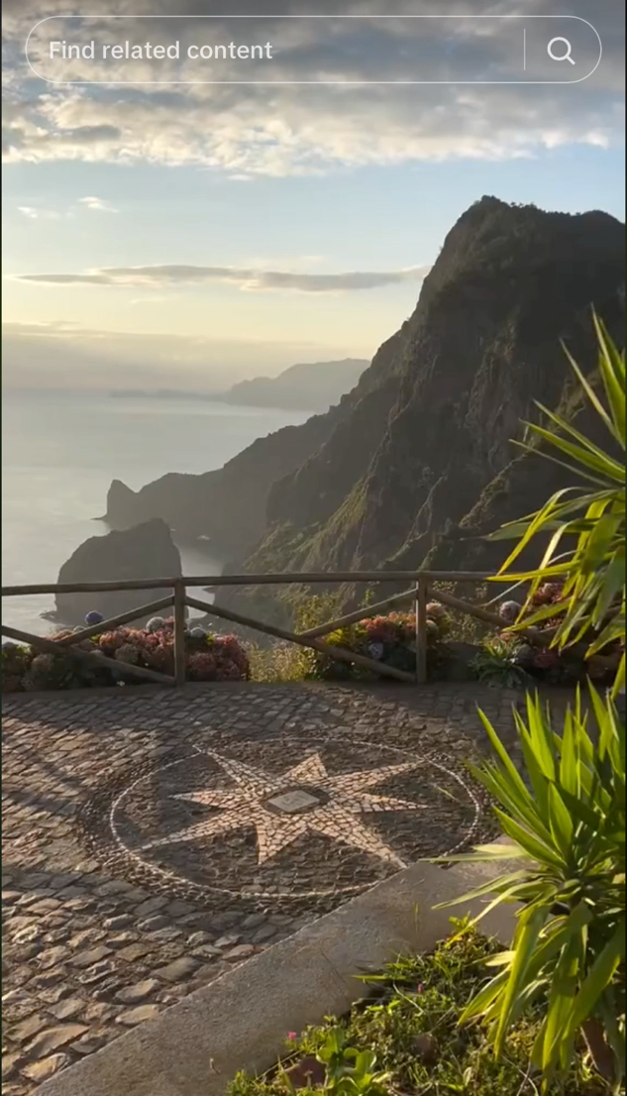

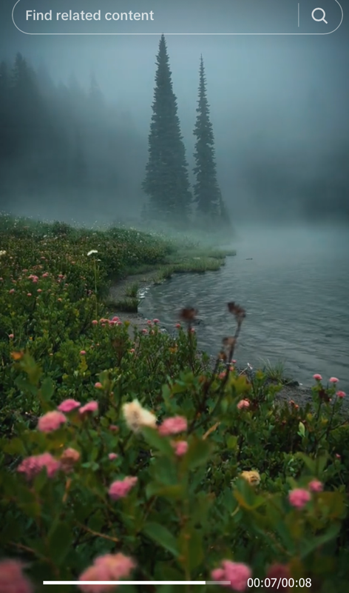
The second one is my personal favourite, and I had a similar vision for content — a girl running in nature! Kind of like female gaze.
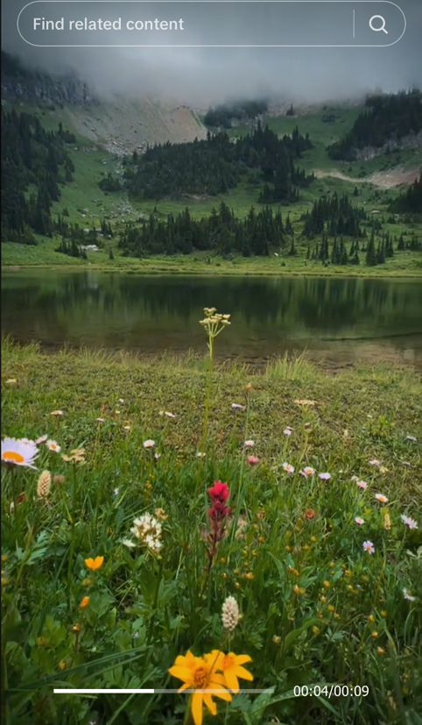

Winter videos would also be similar depicting snow, northern lights, and festive lights.
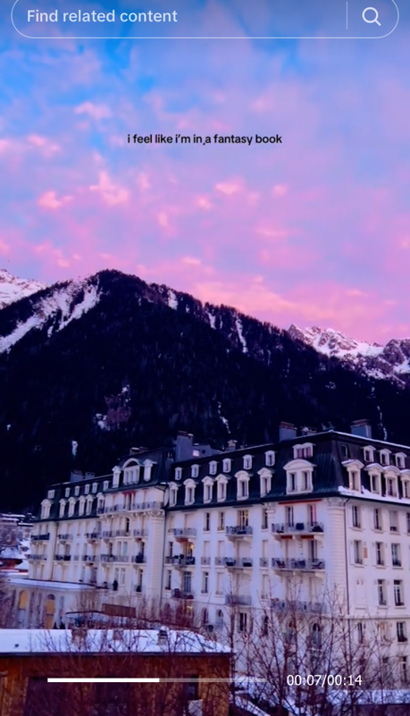

We’ll have some similar short videos featuring local shops or Exchange District and other historical places (these videos would look so awesome in the fall or rainy seasons making it aesthetically pleasing).
- Souls Connect Here
It’s difficult to find commercials that align with my vision, but I still got an example.
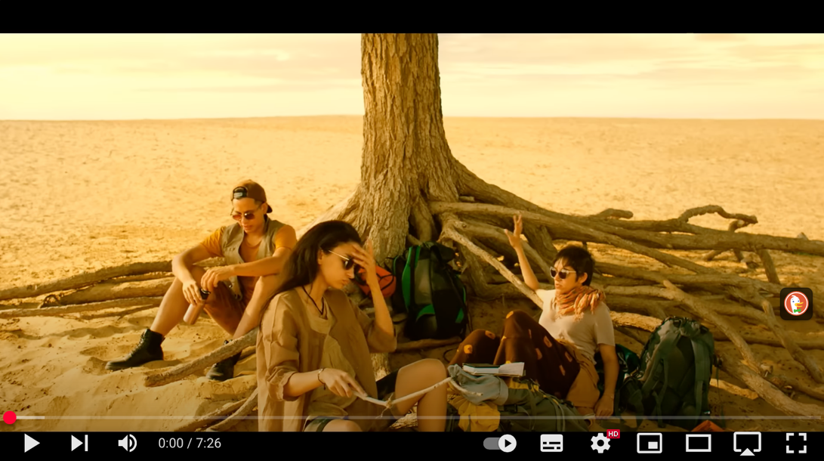
This YouTube video has a series of travel commercials combined in one — all for one destination. It doesn’t have English subtitles so it could be difficult to understand, but the series follows a theme of “what does visiting Rajasthan mean person to person.” Some are heartfelt, some are funny but overall, the first, second, fourth and the sixth one is the vibe I want to go with. Some have minimal to no dialogue, so you’ll understand. Honestly, I believe you’ll understand each one of those commercials based on their context!
Some other examples could be:
- A solo traveller being invited to share a meal during some kind of Manitoba street festival.
- A couple joining a Cree Elder’s storytelling circle.
- A daughter and a mother had a mini fight related to something while exploring Manitoba. The father takes them to a local Manitoba Indigenous owned shop where the mother and daughter buy small gifts for each other — they remember what each other wished for as a gift.
“Manitoba reminds you what you’re really looking for.”
I’m not sure if this is a real commercial which I asked AI to provide me with, but it’s another example of what my vision looks like.

Airbnb – “Until We Belong” (Día de los Muertos)
Synopsis: A white traveler in Mexico is welcomed into a local family’s Día de los Muertos celebration, honoring a loved one together.
- Cultures Live Here
Some of the examples above could tie into this pillar too!
First, we can focus on historic views. Locations we could feature: Immaculate Conception Church of Cooks Creek, Prince of Wales Fort National Historic Site and Bella’s Castle.

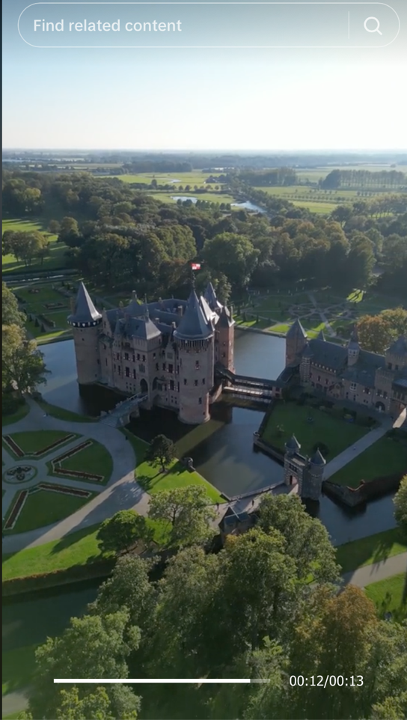
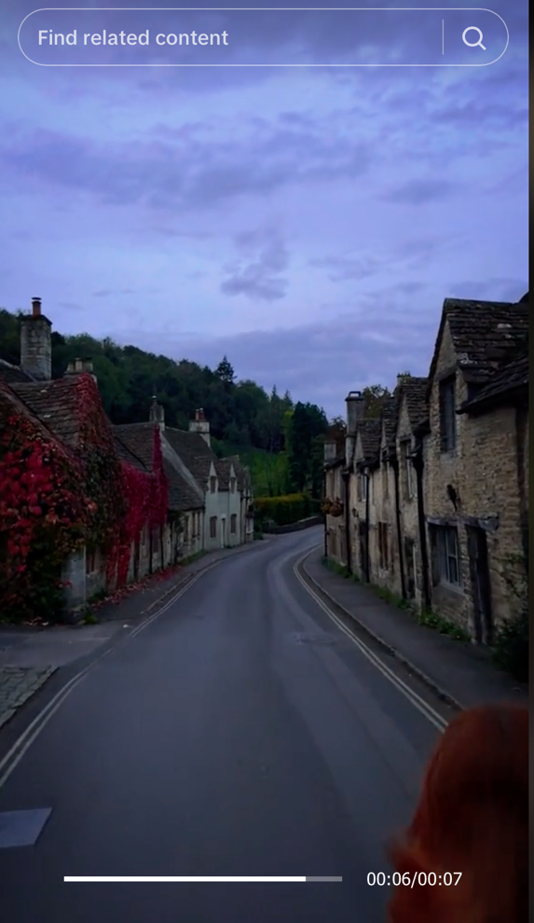

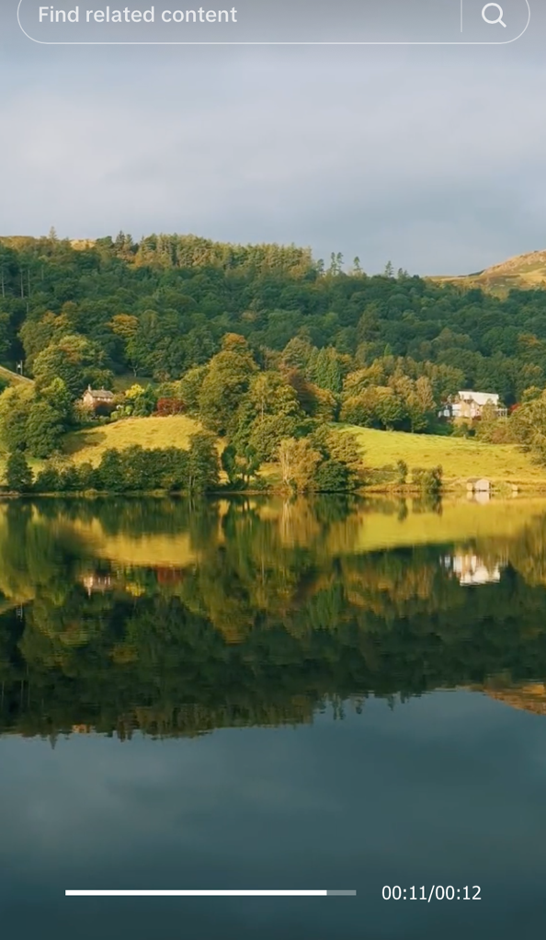
Here’s an example of how we could show Manitoba’s diverse culture:

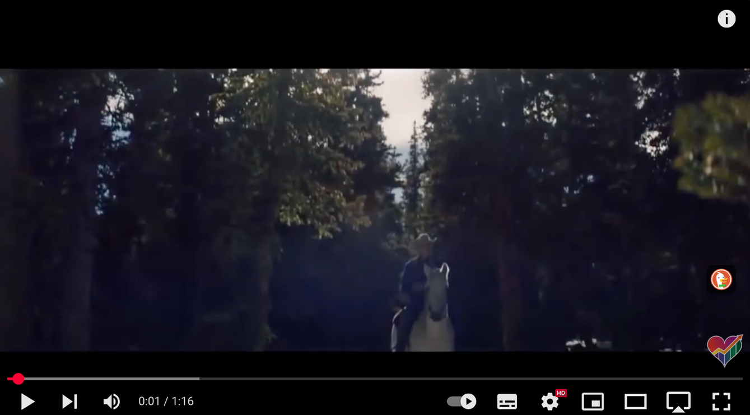

I asked for a real example from AI, and it gave me this:

TD Bank – "All Gifts Are Good" (Eid & Christmas)
A Muslim family and white neighbor exchange gifts during their respective holidays.

I tried to look for the commercial but couldn’t find it, so I’m not sure if this commercial is real but this is the direction I’m leaning towards.

Event Ideas/Partnerships

- Travel Manitoba hosting a “Fantasy Gala/Ball” for the bookworm people each year. You have no idea how big of an audience the BookTok/Bookstagram community is! You mention Aaron Warner or Fourth Wing or ACOTAR and see the havoc it will bring about. I have turned my personal account into a BookTok (TikTok) one and have friends from all over the world. And this is one of the best ideas if we want to attract Canadians. We can take some inspiration from the Second Star Event on Instagram. They are one of the bests I’ve seen, and they do it for the American audience. Let’s do this for our Canadian audience!

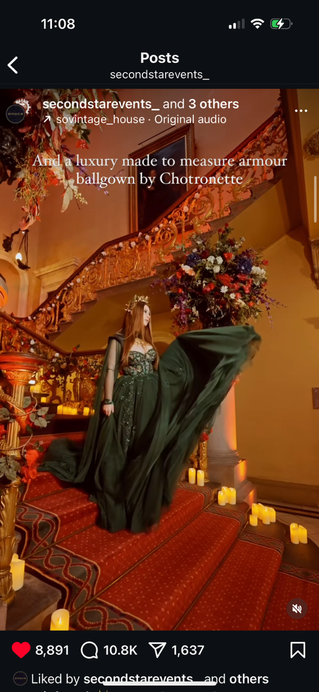

- A pop-up market where Indigenous owned business come together and show their work. This could also include Edlers teaching circle on Indigenous heritage and culture. Some businesses that Travel Manitoba could collaborate with are Mother Earth Essentials and Creative Manitoba.
- Festival du Voyageur: capture families together
- Parks Canada: family hikes

Potential Influencers to collaborate with: THIS IS INSANE BUT… DAVID BASZUCKI, CO-FOUNDER OF ROBLOX. He was born in Winnipeg to his parents who were descended from Ukrainian immigrants. We can have him share his childhood memory from Winnipeg?

Other influencers include Ice Hockey or Basketball Players, and artists.

Here’s a list of well-known artists and players from Winnipeg — who are quite old now, but we can feature them and their work in our ads or collaborate with them on events.

Contact

Thank you for reading this strategic communication plan.
For further information on this plan, please contact:

Shruti Nigam
PR Major, Creative Communications
Mobile Phone: 204 904-9889
E-mail: nigam123shruti@gmail.com

