
Project Brief
Project: Shelmerdine Campaign Plan
Client: Shelmerdine Garden Centre
Prepared For: Hannah Pratt
Prepared By: Shruti Nigam
Date of Brief: April 11, 2025

The Big Idea and Overview
Campaign name: When Life Gives You Gardening!
Inspired by the recent famous and emotional K-drama called “When Life Gives You Tangerines,” that teaches the sacrifice our parents do for us, this event series/workshops bridges generations through gardening.
A monthly workshop series where Gen Z/Millennials team up with parents/grandparents to:
- Pot a plant together (e.g., herbs, or flowers)
- Learn heirloom gardening tips from elders
- Compete in lighthearted challenges ("Best Family Planter" award)
- Take home a "family plant care calendar" to nurture their creation
This is a perfect way to spend time, reconnect, reflect, and appreciate the hard work our parents do.

Objectives
- Strengthen cross-generational connections by having 60% of workshop participants attend as multi-gen family units.
- Position Shelmerdine as Winnipeg's hub for heritage gardening knowledge.
- Develop 5+ family gardening stories for evergreen marketing content.
- Increase weekday workshop attendance by 25%.
- Convert 30% of workshop families to loyalty program members.

Target Audience & Key Messages
- Primary: Grandkids aged 5-30.
Key message: You get to bring your parent/grandparent for a bonding moment while learning about gardening and having fun competing in competitions. Make memories and strengthen your bond with them with us.

- Secondary: Parents and Grandparents aged 35-80.
Key message: You will get to bond stronger with your kids/grandkids while sharing your knowledge/wisdom about gardening to our workshop. You will get to experience a heartwarming experience.

- Tertiary: Local businesses or community groups interested in collaborating or attending the workshops (garden clubs, schools, senior centers).
Key message: You will get to have fun and strengthen your relationships with the community while learning new skills. The workshop will leave you with lasting memories and results.

Insights from Marketing Audit
- Instagram performs best for engagement (1.2K interactions).
- High email open rates (50%) make newsletters ideal for promotions
- Website needs SEO optimization for "gardening workshops Winnipeg."
- Winter months show decreased engagement - opportunity for indoor gardening topics.

Tactics
The campaign will start with an introduction reel on Instagram featuring the ambience/inside of Shelmerdine Garden Centre and introducing the campaign.
We will use Instagram and TikTok to target our primary audience. To target our secondary audience, we’ll use Facebook.
Social Media:
- Throwback Carousels –– Carousel photos of grandparent’s vintage garden photos and their grandkids recreating the scene today.
- #WhenlifegivesyouGardening story of the week –– A simple post of a picture of a grandparent and their grandkids following with their life story in the caption, journalistic style with quotes from grandparents and the grandkids.
- Same as #2 but with a short picture video of the family.
- Videos of elders sharing their heirloom gardening skills.
- A behind-the-scenes of grandparent, parents and grandkids bonding through the workshop.
Note: Some of the videos can be posted on all social media platforms.

Post-Event Engagement:
- Email families their workshop photos with text: "Your love story continues at home — keep your plant alive for Season 2!"
- TikTok & Instagram series: "When Life Gives You… Plant Fails" (funny family bloopers)

Mandatory Content:
- Intro reel on Shelmerdine’s Instagram and Facebook Page.
- #WhenlifegivesyouGardening story of the week
- A behind-the-scenes of grandparent, parents and grandkids bonding through the workshop.
- Videos of elders sharing their gardening skills.

Additional Posts:
- Gardening 101.
- Teaser reels or story highlights.
- Story Q&A.
- Blog Posts

Content Pieces
- Introduction Post Example:
I used the most famous and most used sound from this K-drama to introduce the campaign.
Goal: Drive campaign awareness and initial sign-ups, targeting 500+ likes and 100+ workshop link clicks in the first 48 hour.
Caption: It’s time to strengthen your bond more with your parents and grandparents ––through Shelmerdine’s #WhenLifeGivesYouGardening workshops! Spend a fun time together and make some heartwarming & long-lasting memories with them. Follow the link to register for the workshops and stay tuned for more information! #WhenLifeGivesYouGardening #Shelmerdinegardeningcentre.
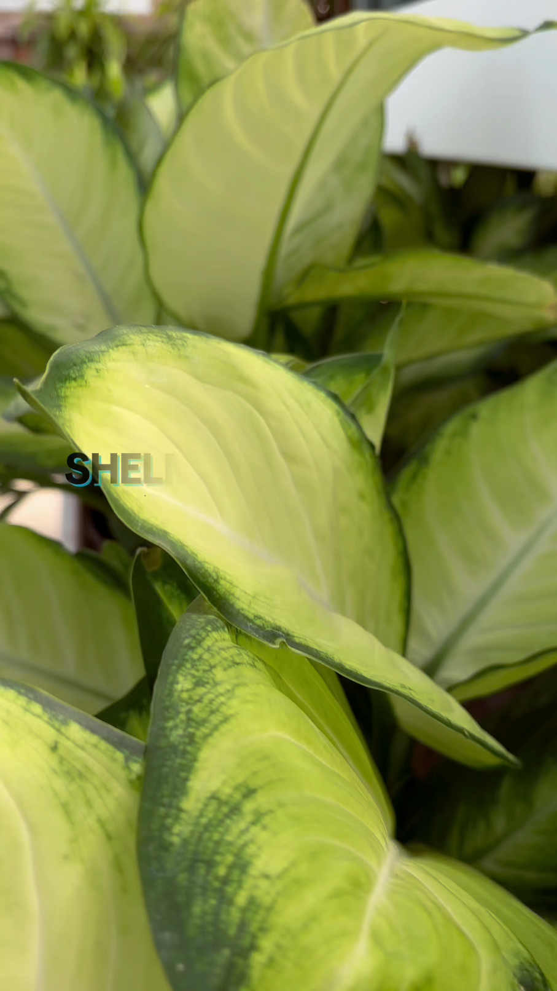

- #WhenLifeGivesYouGardening Story of the Week Example Post:

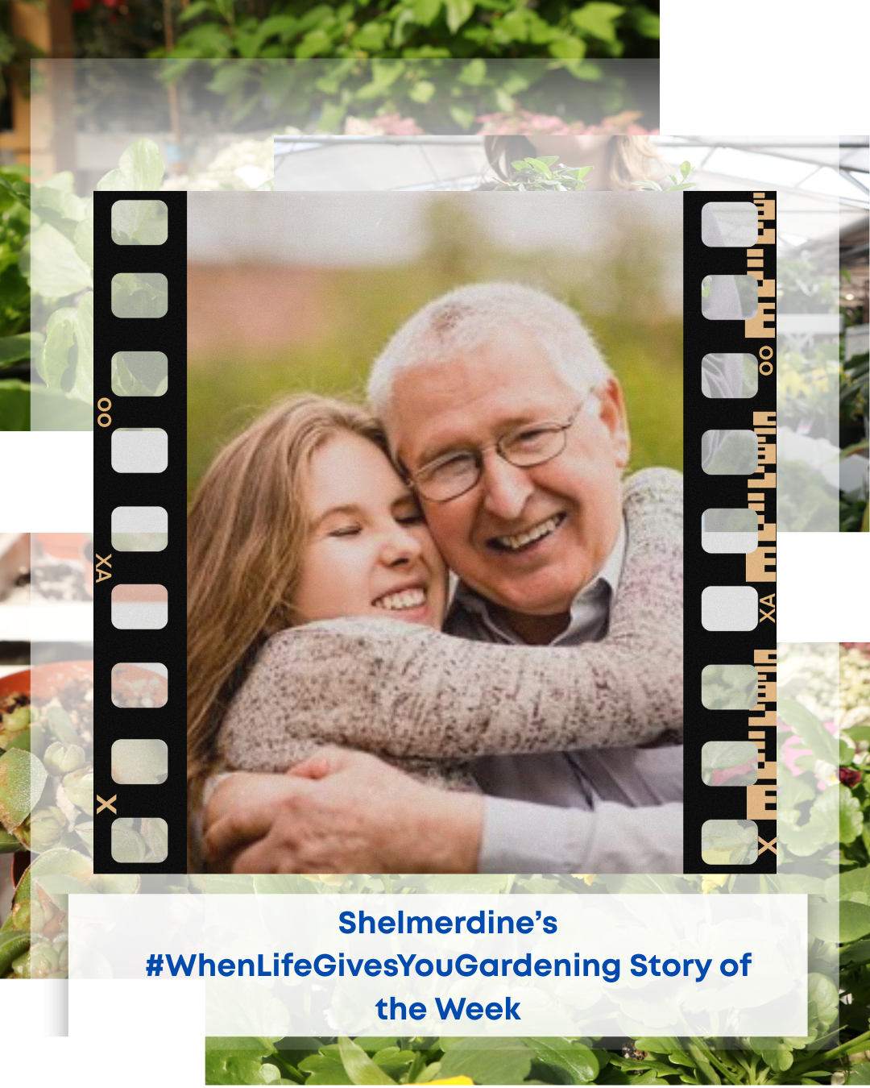

Goal: Sharing/Saving the post at least 50 times per month (showing they find it valuable enough to revisit or send to others).
Submitting 30+ personal stories/photos of their own family gardening moments (to build authentic community content).
Caption: “My grandfather is the most genuine and honest person in my family. I always wanted to do more for him and make him proud of me. Part of me regretted not being able to spend time with him because of my college. But now that I have my summer holidays, I can take my grandfather to Shelmerdine for some fun bonding time! My grandfather also has a garden of his own and is an environment enthusiast. I can’t wait to learn about gardening from him,” says Amanda, 21. #WhenLifeGivesYouGardening #WhenLifeGivesYouGardeningSOTW #Shelmerdinegardeningcentre.

Social Content Calendar:
Here’s an over two months content calendar for the campaign –– June 1, 2025, to August 15, 2025.
Date | Platform | Content Type
June 1 | Instagram + Email | Campaign launch
June 8 | Instagram + Email | #Whenlifegivesyougardening story of the week and blog post about it that is shared in the emails.
June 11 | Instagram + TikTok+ Facebook | A behind-the-scenes of grandparent, parents and grandkids bonding through the workshop.
June 15 | Instagram+ Email | #Whenlifegivesyougardening story of the week and blog post about it that is shared in the emails.
June 18 | Instagram + Facebook | Throwback Carousels –– Carousel photos of grandparent’s vintage garden photos and their grandkids recreating the scene today.
June 22 | Instagram+ Email | #Whenlifegivesyougardening story of the week and blog post about it that is shared in the emails.
June 26 | Instagram + TikTok+ Facebook | Videos of elders sharing their gardening skills.
June 29 | Instagram+ Email | #Whenlifegivesyougardening story of the week and blog post about it that is shared in the emails.
July 2 | Instagram + TikTok+ Facebook | A behind-the-scenes of grandparent, parents and grandkids bonding through the workshop.
July 5 | Instagram+ Email | #Whenlifegivesyougardening story of the week and blog post about it that is shared in the emails.
July 9 | Instagram + Facebook | Throwback Carousels –– Carousel photos of grandparent’s vintage garden photos and their grandkids recreating the scene today.
July 12 | Instagram+ Email | #Whenlifegivesyougardening story of the week and blog post about it that is shared in the emails.
July 16 | Instagram + TikTok+ Facebook | Videos of elders sharing their gardening skills.
July 19 | Instagram + Email | #Whenlifegivesyougardening story of the week and blog post about it that is shared in the emails.
July 23 | Instagram + TikTok+ Facebook | A behind-the-scenes of grandparent, parents and grandkids bonding through the workshop.
July 26 | Instagram+ Email | #Whenlifegivesyougardening story of the week and blog post about it that is shared in the emails.
July 30 | Instagram + Facebook | Throwback Carousels –– Carousel photos of grandparent’s vintage garden photos and their grandkids recreating the scene today.
August 3 | Instagram+ Email | #Whenlifegivesyougardening story of the week and blog post about it that is shared in the emails.
August 6 | Instagram + TikTok+ Facebook | Videos of elders sharing their gardening skills.
August 10 | Instagram+ Email | #Whenlifegivesyougardening story of the week and blog post about it that is shared in the emails.
August 12 | Instagram + TikTok+ Facebook | A behind-the-scenes of grandparent, parents and grandkids bonding through the workshop.
August 15 (Campaign Over) | Instagram+ Email | #Whenlifegivesyougardening story of the week and blog post about it that is shared in the emails.
August 20- 25 | Instagram + TikTok+ Email | "When Life Gives You… Plant Fails" (funny family bloopers).

Evaluation
Objective 1. Cross-Generational Connection Success
- Metric: % multi-gen family units attending
- Tool: Registration surveys (ask "Who are you attending with?")
- Data Source: Sign-up forms + on-site check-ins
- Target: 60% of attendees are families (Gen Z + parent/grandparent)
- Bonus Insight: Track repeat family attendees

Objective 2. Heritage Gardening Positioning
- Metric: UGC featuring heirloom gardening tips
- Tool: Instagram/TikTok hashtag #WhenLifeGivesYouGardening
- Data Source: Social listening tools + manual tally
- Target: 5+ authentic family stories shared per month
- Bonus Insight: Monitor mentions of "tradition" or "family recipe" in posts
Objective 3. Content Growth
- Metric: Evergreen content pieces created
- Tool: Google Drive folder tracking (videos, testimonials)
- Data Source: Marketing team content calendar
- Target: 5+ family story videos (BTS footage + interviews)
Objective 4. Attendance Boost
- Metric: Weekday workshop sign-ups
- Tool: CRM comparison
- Data Source: Registration timestamps
- Target: 25% increase in attendance
Objective 5. Loyalty Program Conversion
- Metric: New loyalty sign-ups post-workshop
- Tool: Discount code redemption tracking
- Data Source: Klaviyo segments
- Target: 30% of families join loyalty program
- Bonus Insight: Track if these families return within 3 months

Future Optimization
Final Report: Summarize attendance, social growth, sales impact, and participant quotes.
- If multi-gen attendance <50%: Add a "Bring Your Elder" discount.
- If UGC stories <3/month: Host a giveaway for best family story.
- If attendance lags: Partner with cafes for indoor events.
- If loyalty sign-ups <20%: Offer immediate 10% off for joining at workshops.



